Project Summary:
My plate project is an opportunity to learn more about your own eating patterns and identify gaps in food groups which can impact your nutritional health.
Objectives
The student will:
- Demonstrate knowledge of the dietary goals and guidelines set for Americans, by evaluating nutritional adequacy of diets using the USDA My Plate.
- Use quantitative analytical skills to evaluate and analyze nutrient analysis data using computer and emerging technologies effectively.
- Synthesize information learned from previous course content to assess and analyze their dietary intake.
On the Food Intake Record form, you will record everything you eat for 3 days. Choose 3 consecutive days, one being a weekend or holiday. Next, generate a meal plan check list using the Choose My Plate tool, and analyze your meal plan.
You will then, in essay form, write a summary and analysis of your diet intake identifying the areas of strength and areas of weakness. And what you could do to improve your intake to make a more complete and nutritionally balanced meal plan.
Before you begin, review the detailed instructions below. The project will be graded based on completeness. Pay attention to portion sizes, condiments etc. added to meals and snacks. You will not be judged for the quality of your diet, but this project may be an opportunity to improve your diet and your health.

Instructions:
Step 1:
Complete 3 days of food intake records.
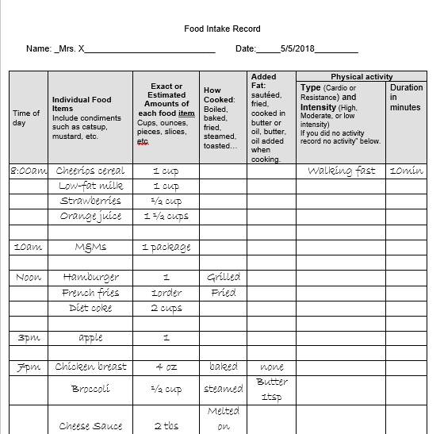

Step 2:
Go to My Plate. Gov https://www.choosemyplate.gov/MyPlatePlan

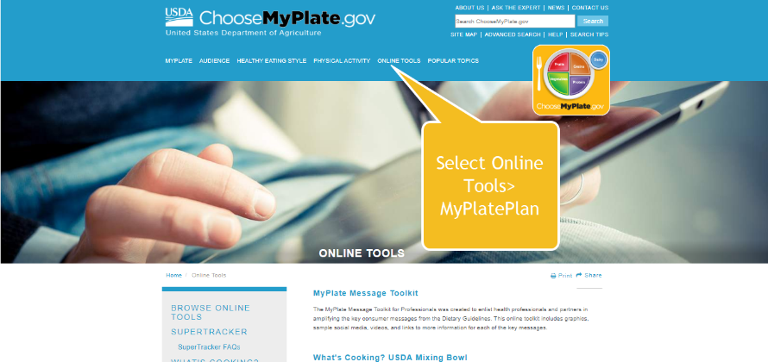

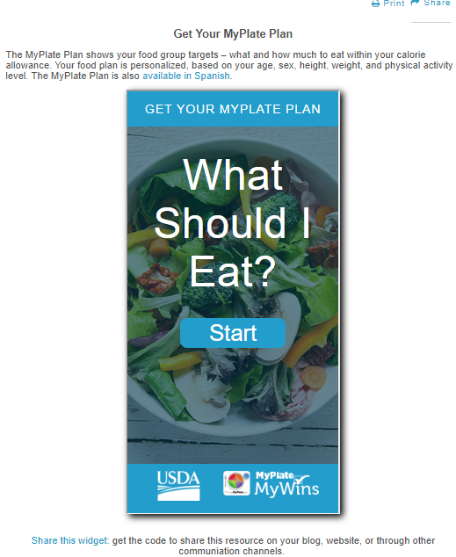

You will enter your personal profile information once you select Start.
You will be given a My Plate Daily Checklist which will guide you on the recommended My Plate food groups to meet your nutrient needs.
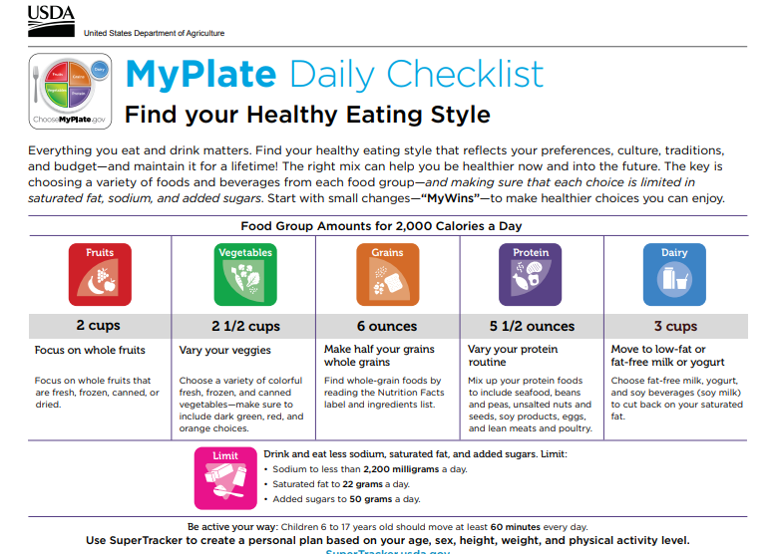

You will also see the MyPlate Daily checklist. Using your food records, complete the MYPlate Daily Checklist. You should use one checklist for each day’s food record.
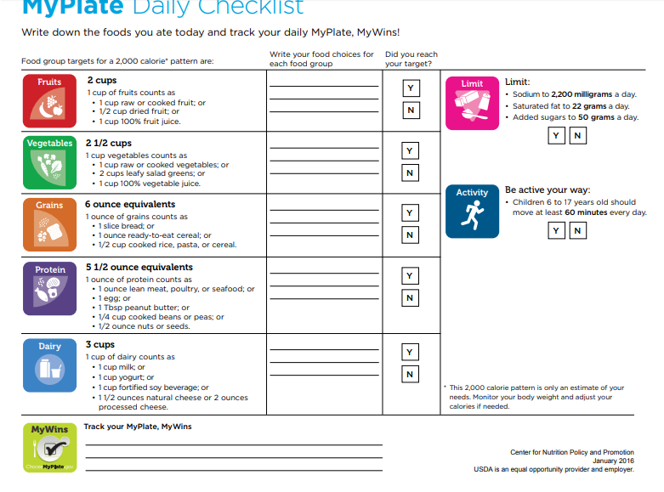

Step 3:
You will determine a 3 days average intake of each of the food groups which you will gather from the foods you recorded on your MyPlate Daily Checklist.
Food Group | 3-Day Average | Target (from My Plate checklist) | Target Met?
FRUIT | 2 cups Fruits | 2 cups
VEGETABLE | 0 | 2 ½ cups
GRAIN | 2 ½ grain | 6 ounces
PROTEIN | 6 protein
DAIRY | 3 milk
OTHER - Fat | 6 tsp Butter
OTHER - Sugar | 4 Tbsp sugar  2 tsp honey

Step 4:
Answer the following questions in essay format. Include references; consider grammar and spelling.
- Did you meet your target? Were you under/over?
- Compare each section of the plate with what you ate, and use this information to write a detailed analysis.
- Discuss reasons your intake either exceeds, meets or is below your target. Make suggestions where changes could be made in order to meet your target amounts.
- Did you experience any portion distortion? We you surprised at how many (or how few) calories were in something that you ate? See MyPlate Portion Distortion: https://www.choosemyplate.gov/tools-portion-distortion
Example: My intake of fruits exceeded my target goals. I met my goal at breakfast, but I continued to eat fruit all day. Even though fruits provide good sources of vitamins and minerals, exceeding my goal every day could lead to extra calories which could result in weight gain (Nutrition and You Pg.___) I was surprised to find out that the bagel, which I love, had four servings of grain! I will switch Tomas’ bagels which I can buy at Publix, and only have 2 servings of grain, therefore half the calories. According to ChooseMyPlate.gov Grains, I should eat 10 servings per day. If I start the day eating 4, I will likely overeat by the end of the day.

- Name at least one nutrient from each food group that you could be at risk if you do not meet (or if you exceed) the recommended amounts.
Example: “for the three days, I ate an average of one serving of vegetable. My intake should be 3-5 servings. Vegetables are good sources of many vitamins and minerals. If I continue to be below my target intake, I might not, for example, meet my requirement for Potassium. Potassium is necessary to help control blood pressure, and is necessary for bone health along with other important functions (Nutrition and You pg. 305).
I could not believe that I ate an average of 10 ounces of meat (protein) per day!! If I continue down this path……….”

Physical Activity
- Rate your activity level as sedentary, moderate or active. How did you do?
- Review the content from MyPlate.gov https://www.choosemyplate.gov/physical-activity-basics
- Refer to the chapters in your text book on Energy Balance, Weight Management and Fitness to assist your written analysis of your physical activity. Use citations from your text to validate your responses.
My Wins (5 bonus points)
What are some small changes that you are planning to incorporate that will help you to cut back on saturated and trans fat, added sugar or sodium? (Discuss at least 3, and explain how you plan to get it done).

Step 5: Submit Assignment
Once completed, submit the assignment online in D2L under the Diet Analysis Folder under the Assessment tab. You will combine all of the reports into one document. Multiple documents will not be accepted. (Assessments → Assignments → Diet Analysis)
Checklist
- Cover sheet: APA formatted. (You do not need an abstract).
- 3-day food record
- My Plate Info
  - MyPlate Daily Checklist (Find your eating style)
  - MyPlate Daily Checklist ( 3 day record)
  - Table including 3-day average and target met/not met
- Written Analysis
- References (APA formatted)

Writing Conventions (grammar, formatting, following directions etc.): 20 points
Although there is no word requirement all of the questions should be answered thoroughly. Based on the assessment, each student’s data will be different and therefore the amount of written assessment will vary. However, most of the written portion of the assignment that successful students have submitted in the past have been between 4-7 pages (not including the reports).

